369ai
H R S U I T E F O R O D O O 1 9

EMPLOYEE MONTHLY REPORT

HR Step-by-Step Guide

Day-wise attendance, late tracking, leave and deductions —
all in one monthly statement, with PDF and Excel export.

A simple guide to generating, reading and exporting the monthly employee report for payroll.

Module Version 19.0.3.0.0 · Odoo 19 · Human Resources

About This Report
The Employee Monthly Report brings attendance, late arrivals and leave together into a single monthly statement. For the month you choose, it works out — for every employee — how many days they worked, how often they were late, how much leave they took, and what should be deducted. The result is a clear figure for what each employee should be paid.
This guide walks you through everything you do with the report, in the order you will do it: generate it, read it, look closer at any employee, and export it for payroll.
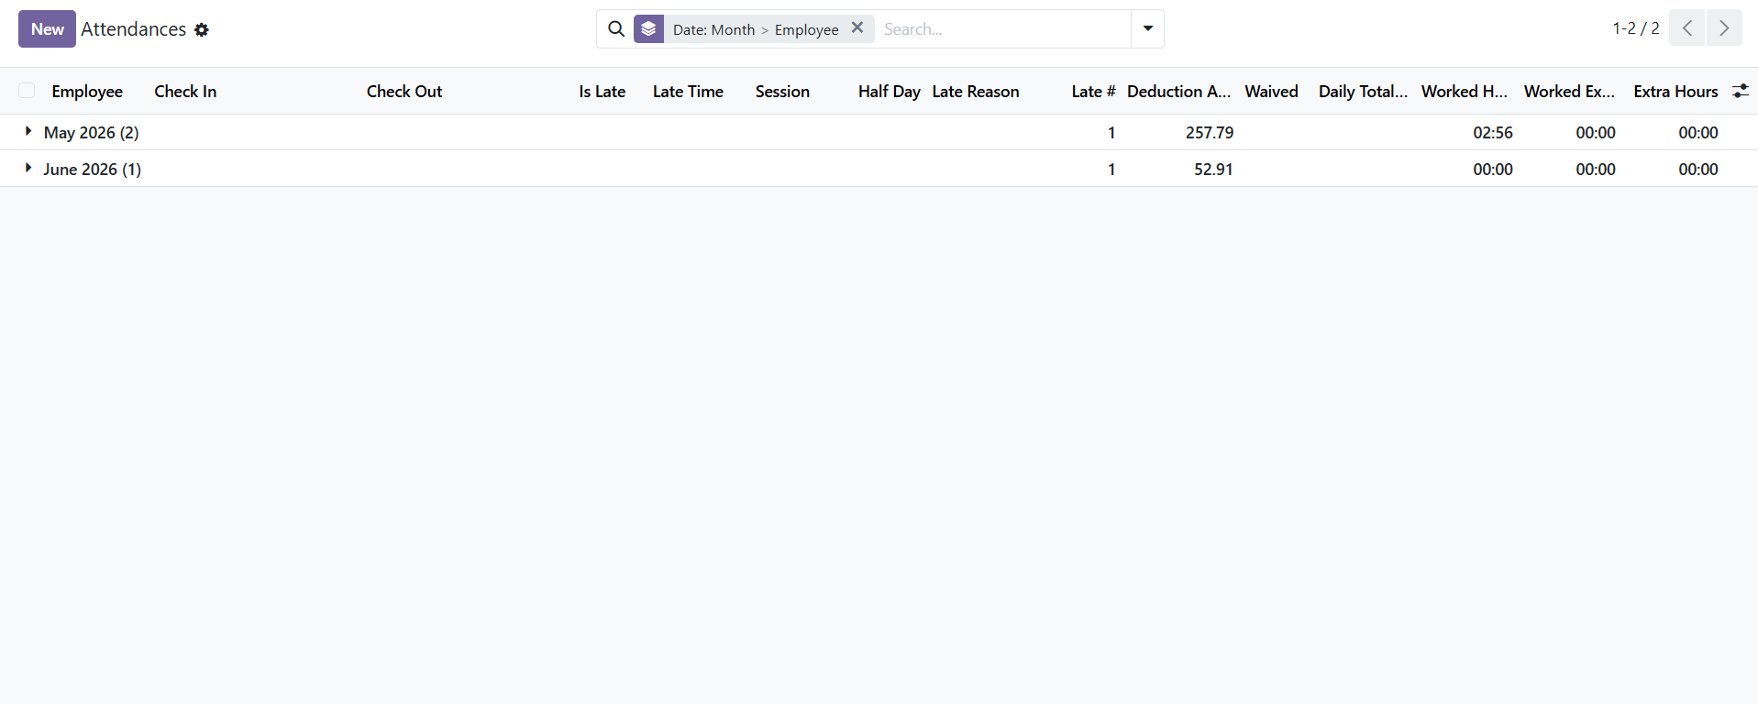
The Employee Report lives in the Attendances app. The monthly figures are built from the attendance, late and leave data you already capture.
What the Report Gives You at a Glance
- A per-employee summary — working days, present days, late days, leave days and deductions.
- A day-wise detail — every date marked as Present, Late, Leave, Absent or Holiday.
- Grand totals — total wages, total deductions and the total final amount across everyone.
- Drill-down — jump from any employee to their day details, late records or leave records.
- Export — a branded PDF and a two-sheet Excel workbook, ready for payroll.
Who this is for: HR Officers who generate the report, HR Managers who verify the figures, and Payroll Staff who use the deductions and final amounts as input to the payroll run.

PART 1 Generating a Report

Everything starts from a short form (a wizard) where you choose the month and who the report is for.
Step 1 Open the Generate Report screen
In Odoo, go to Human Resources → Attendance → Employee Report → Generate Report. A small form opens.

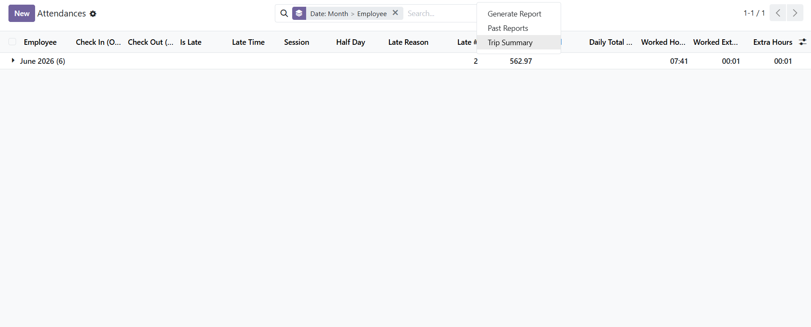
Employee Report menu — choose Generate Report to build a new one, or Past Reports to reopen an earlier report.
Step 2 Choose the Month and Year
In the PERIOD section, pick the Month from the dropdown and type the Year. Both default to the current month and year, so usually you only change them for an older month.
Step 3 Confirm the Company
In the COMPANY section, the company is already filled in with your current company. Change it only if you run more than one company.
Step 4 Choose Who the Report Is For
In the EMPLOYEES section, pick one option:
- All Employees — generates the report for everyone in the company.
- Selected Employees — a tags box appears; type and pick the specific people you want.
You can also set a Department to narrow the report to one team. Leave it empty to include all departments.

TIP Use Selected Employees or a Department when you only need a few people — the report generates faster and is easier to read.

Step 5 Click Generate Report
Tap the green Generate Report button. The report opens with the title “Employee Report - [Month] [Year]”. (Click Cancel instead to close without generating.)

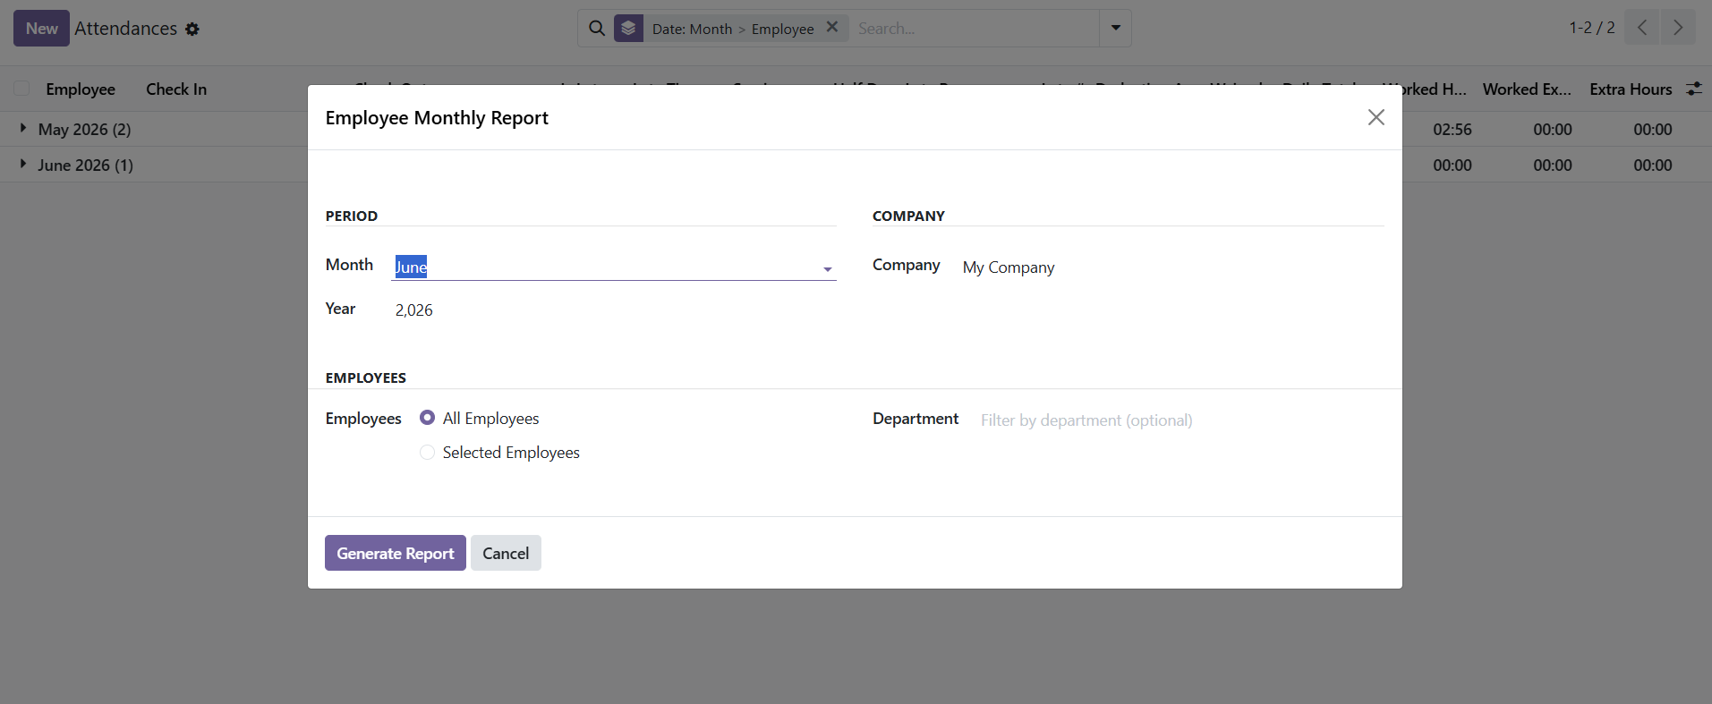
The Generate Report form — set the Month and Year, confirm the Company, choose All or Selected Employees (and an optional Department), then click Generate Report.

PART 2 Reading the Report

The report opens on a single screen. From top to bottom you see the grand totals, then two tabs of detail.
Step 6 Read the Totals Banner
Across the top, a banner shows the company-wide totals:
- Total Late Deductions — money deducted for late arrivals.
- Total Leave Deductions — money deducted for unpaid leave.
- Grand Total Deductions — all other deductions (absences and the rest), shown in red.
- Total Wages — the sum of every employee’s monthly wage.
- Grand Final Amount — the big number: the total you will actually pay.
Step 7 Open the Employee Summary Tab
This tab lists one row per employee. Each row shows their working days, present days, late days (after grace), late time, paid and unpaid leave days, wage, total deduction and final amount. A Grand Total row sits at the bottom. Deductions show in red; the final amount is bold.

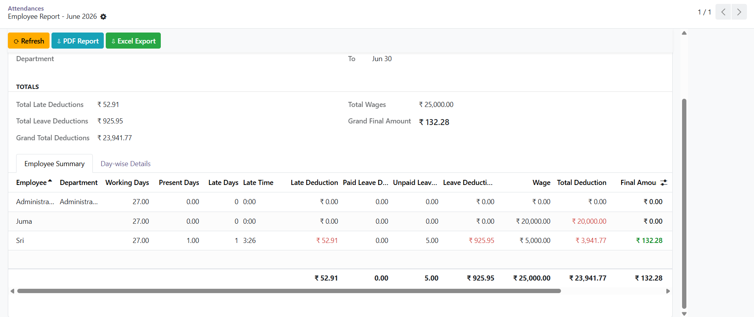
The totals banner across the top, then the Employee Summary tab — one row per employee with a Grand Total at the foot.
Step 8 Open the Day-wise Details Tab
This tab shows every day for every employee, with a colour-coded Day Type so you can scan it quickly:
Day Type | Colour | Meaning
Present | Blue | Normal attendance — shows the check-in time.
Late | Orange | Late arrival — shows minutes late and the reason.
Leave | Green | Approved leave — shows the leave type and whether it was paid.
Absent | Red | A working day with no attendance and no leave (“Not Entered”).
Holiday | Grey | A public holiday — no work expected.
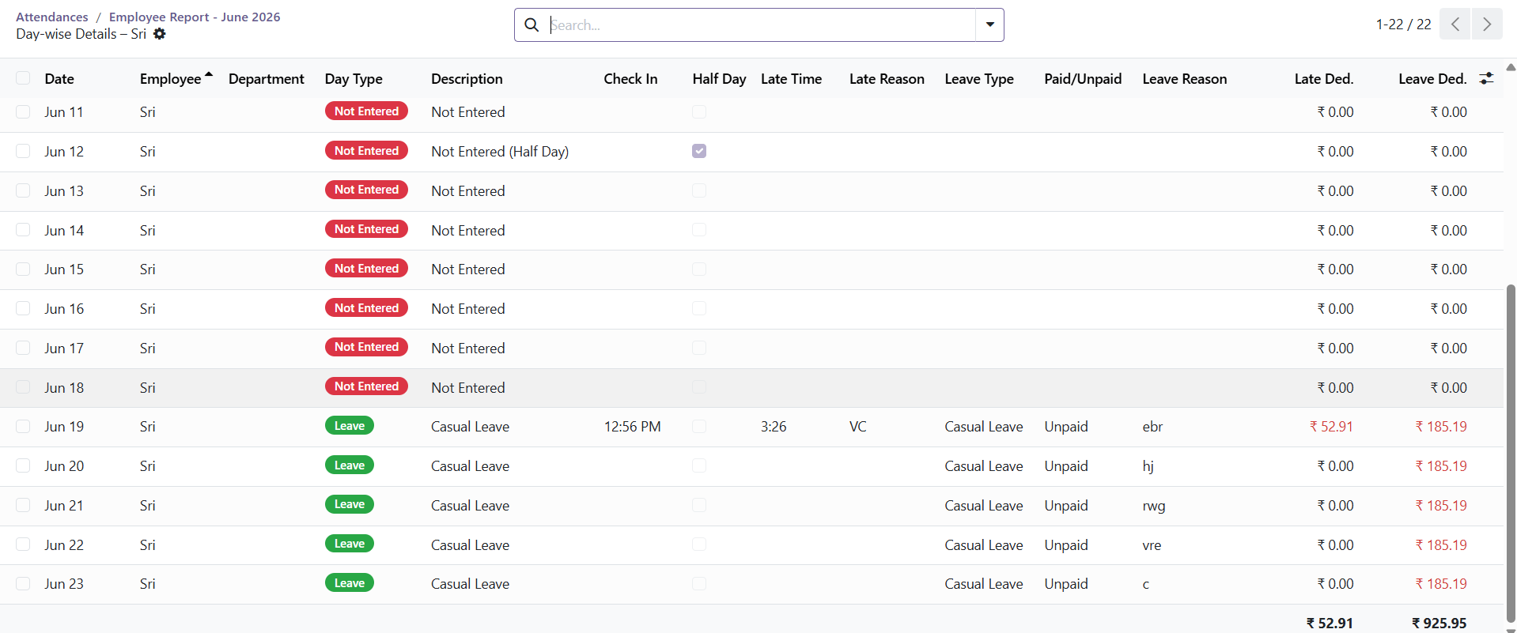
Day-wise Details — every date carries a colour-coded badge (here Not Entered and Leave), with check-in time, late minutes, leave type and the matching deductions.

IMPORTANT The figures always balance: Final Amount + Leave Deduction + Total Deduction = Wage. If you ever doubt a number, this check will reconcile it.

PART 3 Looking Closer (Drill-down)

When a number looks surprising, open the source behind it. On each employee’s summary row you have three buttons.
Step 9 Use the Drill-down Buttons
- 📋 Details — opens that employee’s day-by-day list for the month.
- ⏱ Late — opens the actual attendance records where they were late.
- 🗓 Leave — opens the actual leave requests they submitted.
The Late and Leave buttons are hidden for an employee who had no late arrivals or no leave, so an empty list is never opened.
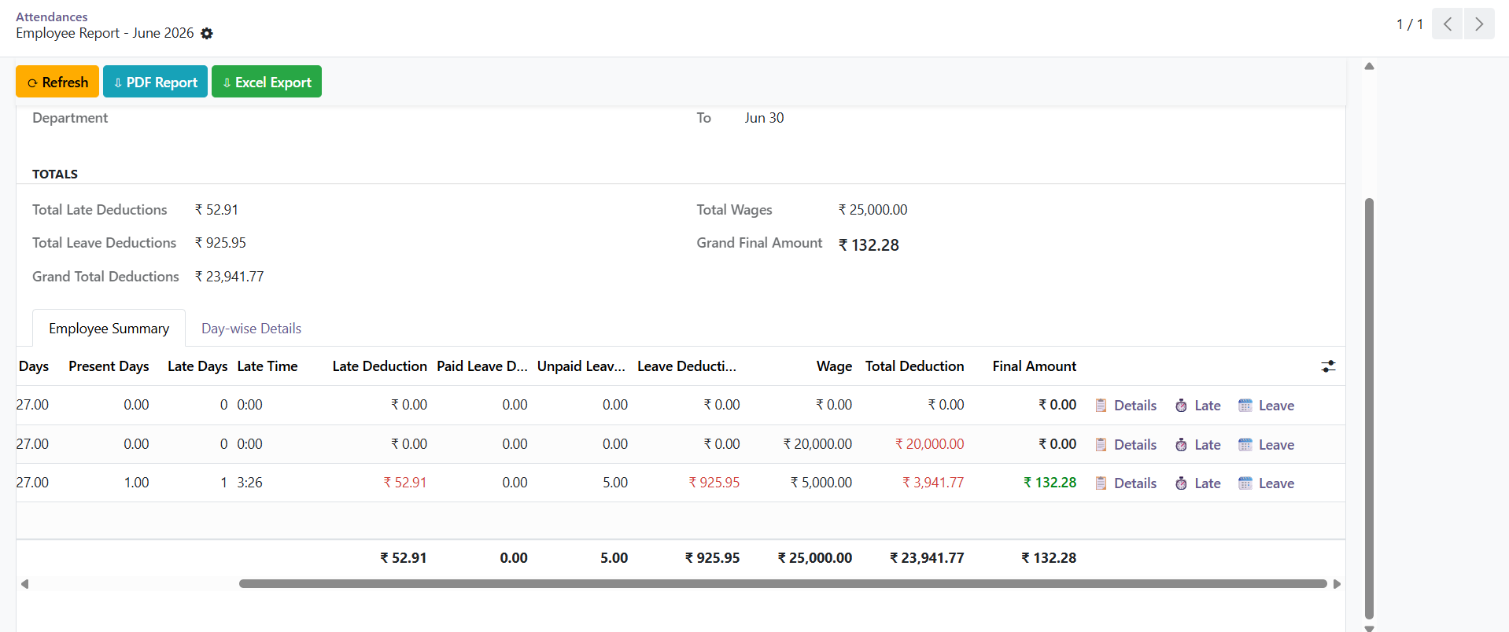
Each summary row carries Details, Late and Leave buttons on the right for one-click drill-down.
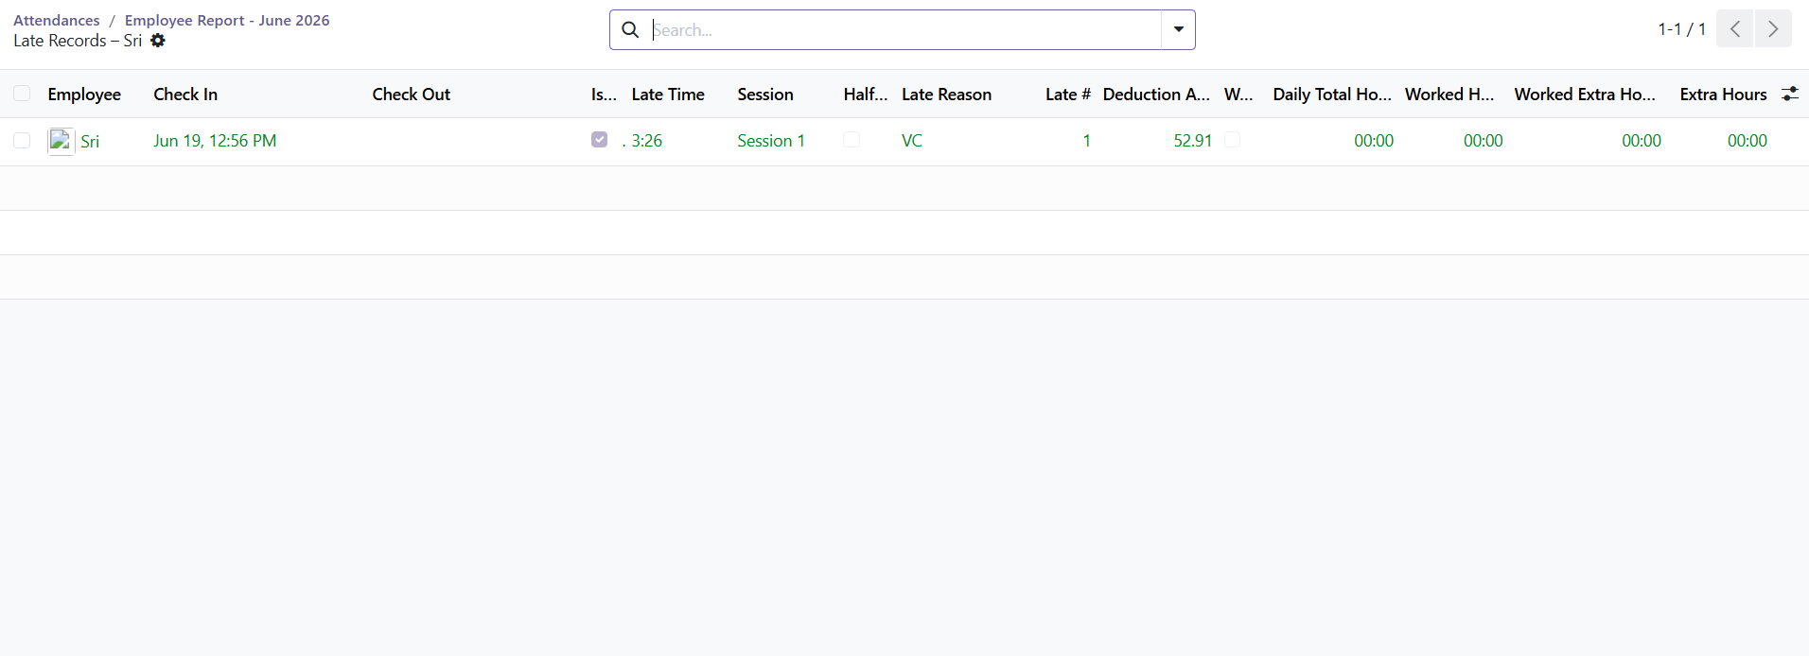
Late — the actual attendance records behind the late deduction, with check-in time, minutes late and the reason.

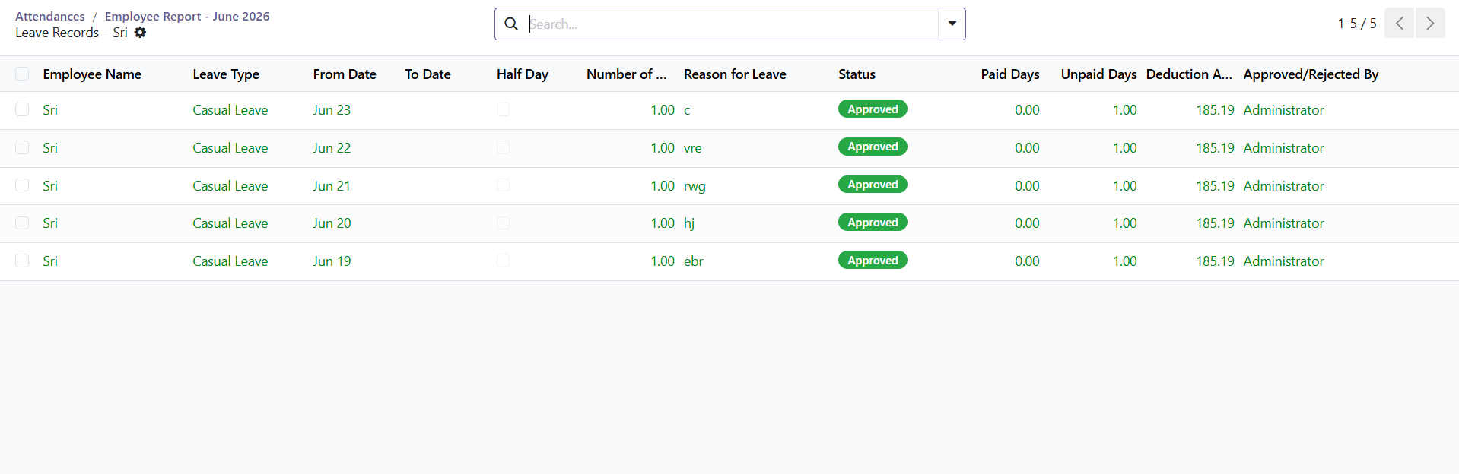
Leave — the actual leave requests behind the leave deduction, with type, dates, paid/unpaid days and approval status.
Step 10 Refresh After a Change
If you change a policy, fix an attendance record, or approve a leave after generating the report, click the ⟳ Refresh button at the top. The report recalculates everything from the latest data.

TIP The report always recalculates late and leave deductions fresh when you refresh — it never shows a stale figure.

PART 4 Exporting the Report

When the figures look right, export the report for payroll or your records. Two buttons sit at the top of the report.
Step 11 Export to PDF
Click ⇩ PDF Report. You get a branded PDF: page one is the summary of all employees, and each employee after that gets their own page with a day-wise table and a small wage / deduction / final-amount box.
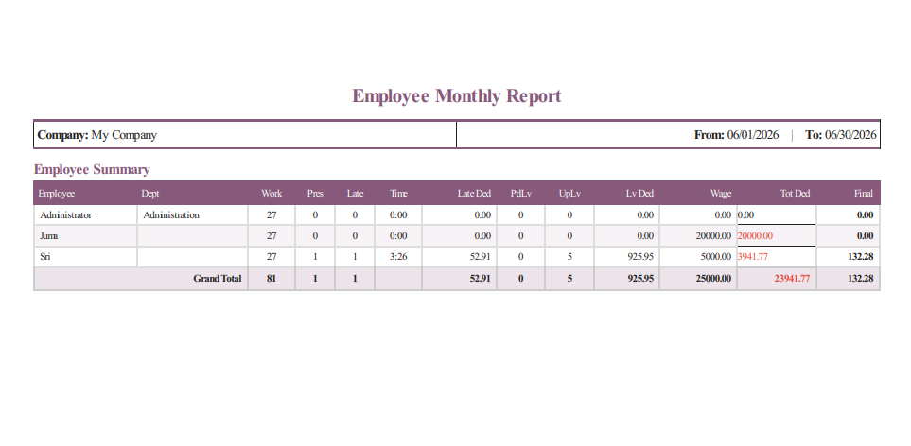
The PDF report — a branded summary of every employee, followed by a dedicated page per person.

Step 12 Export to Excel
Click ⇩ Excel Export to download an .xlsx workbook with two sheets — “Employee Summary” (one row per employee, with grand totals) and “Detailed Entries” (every day-wise line). Use it to email or to feed the payroll run.

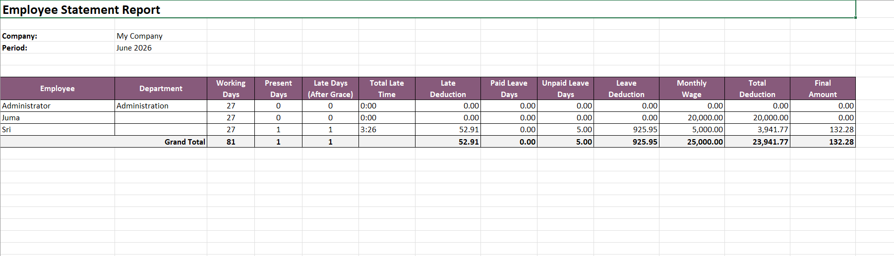
The Excel export — an Employee Summary sheet (shown) plus a Detailed Entries sheet, ready for payroll.

TIP Every report you generate is saved. Re-open an old one any time from Human Resources → Attendance → Employee Report → Past Reports, then export it again.

How the Figures Are Calculated

You do not need the maths to use the report, but here is the short version of where the numbers come from:
- Daily rate = monthly wage ÷ total working days in the month (rounded once).
- Late deduction — applied only after the allowed grace arrivals are used up, and skipped for any late arrival that HR has waived.
- Leave deduction = daily rate × unpaid leave days. Paid leave is not deducted.
- Auto half-day — for split-shift staff, if only one session is attended, that day counts as a half day.
- Final amount = what the employee earned (present + paid leave days) minus late deductions.
Because the daily rate is rounded once, an employee with perfect attendance is paid exactly their wage.
Trip Summary (Field Trips)
The same Employee Report menu also holds a Trip Summary view for companies that use HR Field Attendance. Open Attendance → Employee Report → Trip Summary to see every field trip, grouped by Employee and Date, with these deviation columns:
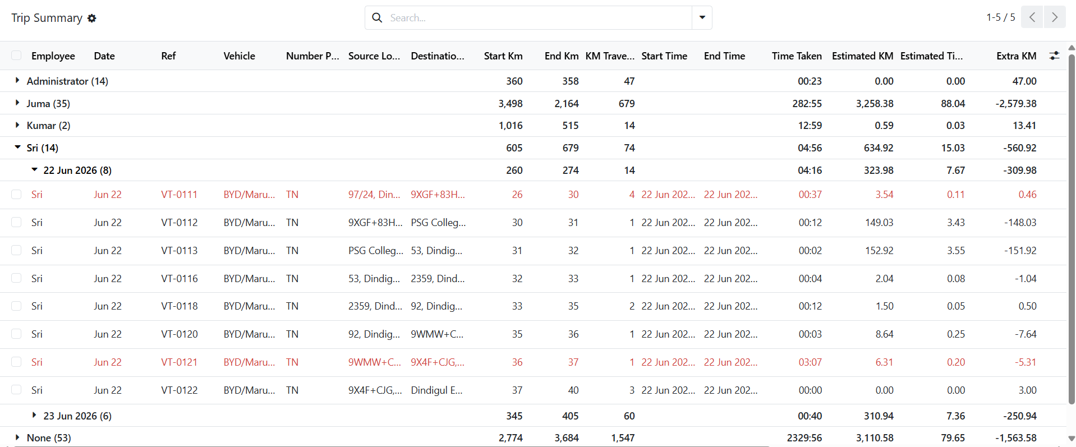
Trip Summary — every field trip grouped by Employee and then by Date, with start/end km, distance travelled, start and end times and the estimated-versus-actual columns.
- Extra KM / Extra Time (Hrs) — how far each trip went over its estimated distance and time.
- Trip Check — Within Estimate or Over — Check; trips that are over are highlighted in red. Use the Over / Check filter to list only those.
- Deviation Reason — the explanation the driver entered for a trip that ran over.
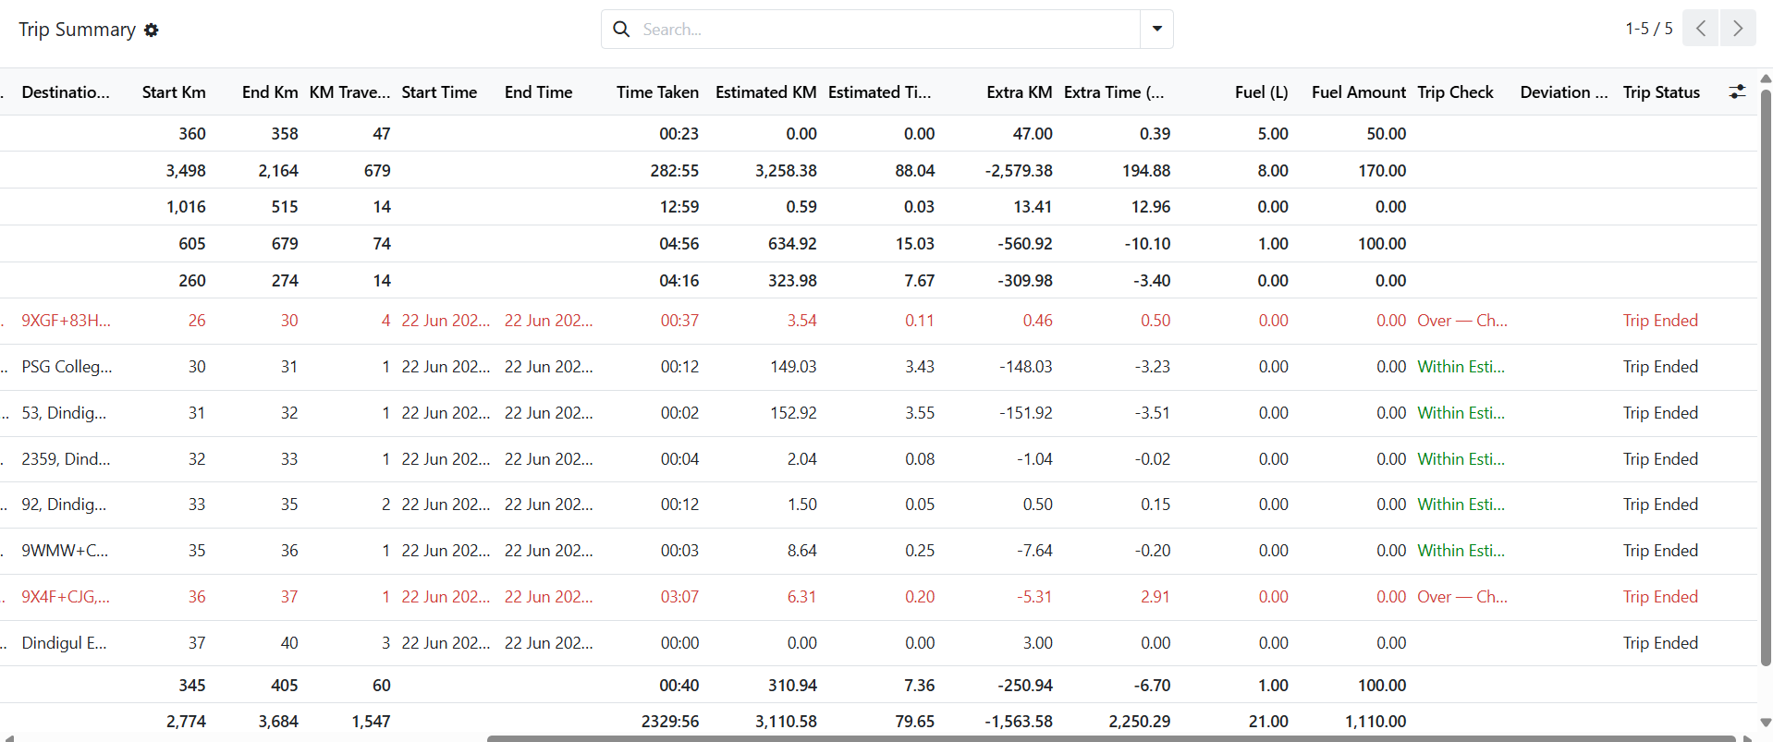
Scroll right for the deviation columns — Extra KM, Extra Time, Trip Check (Over — Check shown in red) and the driver’s Deviation Reason, alongside Fuel, Fuel Amount and Trip Status.
For the full field-trip workflow and how deviations are recorded, see the HR Field Attendance guide.
Quick Reference — Buttons & Tabs
A fast lookup for what each control does.
Button / Tab | When to use it
Generate Report | Create a new report for a month — choose period, company and employees.
Employee Summary | Read one row per employee: days, late, leave, wage and final amount.
Day-wise Details | See every date per employee, colour-coded by day type.
📋 Details | Open one employee’s day-by-day list.
⏱ Late | See an employee’s actual late attendance records.
🗓 Leave | See an employee’s actual leave requests.
⟳ Refresh | Recalculate the report after a policy or data change.
⇩ PDF Report | Export a branded PDF (summary + a page per employee).
⇩ Excel Export | Download a two-sheet Excel workbook for payroll.
Past Reports | Re-open any report you generated earlier.
Things to Remember
- Pick the right month and year before you generate — they default to today.
- Use Selected Employees or a Department to keep large reports manageable.
- Click ⟳ Refresh after any change so the figures stay current.
- Deductions and leave status are recalculated fresh — the report never shows stale numbers.
- Final Amount + Leave Deduction + Total Deduction always equals the Wage.
- Export to PDF or Excel before handing figures to payroll; old reports stay under Past Reports.

- The Trip Summary under this menu shows field-trip deviations (Over — Check) and the reasons drivers gave — handy when a deduction or an absence needs explaining.
— End of Guide —
369ai.Biz | Employee Monthly Report — HR Guide

